SIMATS ENGINEERING
ASSESSMENT TOOL 3

COURSE NAME: COMPUTER NETWORKS
COURSE CODE: CSA07

COURSE OUTCOME COVERED
CO4:
Design network topologies star, mesh, bus, and hybrid using networking devices, transmission media, and cabling standards
(BL2,BL6)
Assessment Tool Weightage: 30%

QUESTIONS: 5 Total Marks:25

Annexure A
Comparative Analysis

Code of Conduct:
I_M.Greeshma /192524195_ (Name / Reg No) certify that this submission is my original work and that I have adhered to the guidelines specified for this assessment. I understand that any violation of academic integrity rules will result in disciplinary action.
Signature of the student:M.Greeshma

1. Star topology is generally more expensive than bus topology because it requires a
central device such as a switch or hub and more cabling to connect each node
individually. In contrast, bus topology uses a single backbone cable, making it low-
cost and easier to install. However, in terms of reliability, star topology is superior
because failure of one node does not affect others, whereas a failure in the main bus
cable can bring down the entire network. Performance is also better in star topology
since data transmission is managed through a central device, reducing collisions, while
bus topology suffers from performance degradation as more devices are added due to
increased data traffic on the shared medium.

Sol :
Star vs. Bus Topology
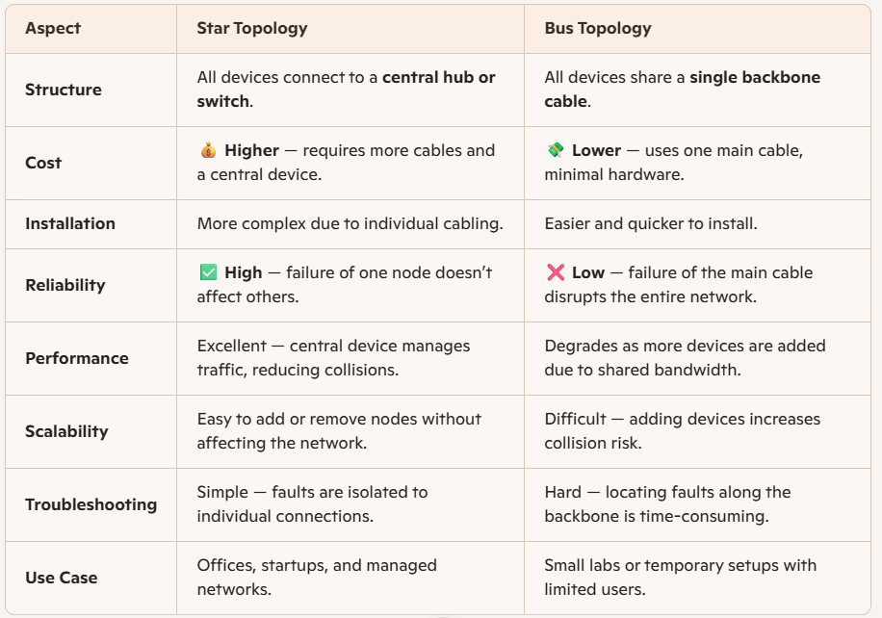

Star Topology
🔹 1. Structure
- All devices are connected to a central hub or switch.
- Each node has its own dedicated cable to the central device.
🔹 2. Cost
- More expensive due to extra cabling and the need for a central device.
- Installation requires more hardware and labor.
🔹 3. Reliability
- Highly reliable — if one node fails, others remain unaffected.
- Only the failed node’s connection is impacted, not the entire network.
🔹 4. Performance
- Better performance — data passes through the central device, reducing collisions.
- Efficient management of traffic ensures faster communication.
🔹 5. Scalability
- Easy to add or remove devices without disturbing the network.
- Ideal for growing organizations.
🔹 6. Troubleshooting
- Simple — faults can be easily identified and isolated at the central hub.
🔹 7. Use Case
- Common in offices, startups, and managed networks where reliability and speed are priorities.
🔸 Bus Topology
🔹 1. Structure
- All devices share a single backbone cable (the bus).
- Data travels in both directions along the same line.
🔹 2. Cost
- Low-cost — minimal cabling and no central device required.
- Easy and inexpensive to install.
🔹 3. Reliability
- Less reliable — if the main cable fails, the entire network goes down.
- A single point of failure affects all connected devices.
🔹 4. Performance
- Decreases as more devices are added due to increased collisions.
- Shared bandwidth limits efficiency.
🔹 5. Scalability
- Difficult to expand — adding more nodes increases collision risk.
- Not suitable for large networks.
🔹 6. Troubleshooting
- Hard to locate faults since all devices share the same cable.
🔹 7. Use Case
- Suitable for small labs or temporary setups with limited users and light traffic.

2. Mesh topology offers very high fault tolerance because every node is connected to
multiple other nodes, providing multiple paths for data transmission. If one link fails,
data can still be routed through alternate paths without disrupting communication. In
contrast, star topology has moderate fault tolerance; while failure of individual nodes
does not affect the network, failure of the central hub or switch can cause the entire
network to stop functioning. Therefore, mesh topology is more robust and reliable in
critical environments compared to star topology.
Sol:

Mesh Topology
- Structure
  - Every node is connected to multiple other nodes.
  - Provides multiple paths for data transmission.
- Fault Tolerance
  - Very high — if one link fails, data reroutes through alternate paths.
  - No single point of failure, ensuring continuous communication.
- Reliability
  - Extremely robust and reliable, ideal for critical environments (banks, military, data centers).
- Performance
  - High performance due to multiple routes, but requires complex routing protocols (OSPF, BGP).
- Cost & Complexity
  - Expensive — requires more cabling and configuration.
  - Complex to design and maintain.
🔸 Star Topology
- Structure
  - All nodes connect to a central hub or switch.
  - Communication is managed through this central device.
- Fault Tolerance
  - Moderate — failure of one node does not affect others.
  - But if the central hub/switch fails, the entire network goes down.
- Reliability
  - Reliable for small to medium networks, but dependent on the central device.
- Performance
  - Better than bus topology — central device reduces collisions.
  - Limited by the capacity of the hub/switch.
- Cost & Complexity
  - Less expensive than mesh — fewer cables and simpler design.
  - Easy to install and manage.

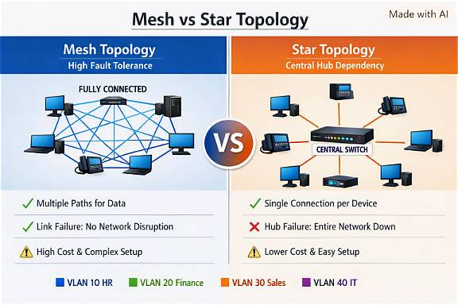

3. Bus topology is simple and easy to install because it uses a single backbone cable with
minimal connections, making it suitable for small networks. On the other hand, mesh
topology is highly complex to install as each node must be connected to every other
node, requiring a large number of cables and ports. This complexity increases
significantly as the number of devices grows, making mesh topology time-consuming
and costly to implement compared to the straightforward setup of bus topology.
Sol :

Bus Topology
🔹 1. Structure
- All devices share a single backbone cable (the bus).
- Data travels along this cable, and each device listens for messages addressed to it.
🔹 2. Installation
- Simple and easy to install — minimal cabling and connectors.
- Requires only one main cable and terminators at both ends.
- Ideal for small networks with limited devices.
🔹 3. Cost
- Low-cost — fewer cables and no central device needed.
- Economical for small setups like classroom labs or temporary networks.
🔹 4. Complexity
- Low complexity — straightforward setup and minimal configuration.
- Easy to understand and maintain.
🔹 5. Scalability
- Limited — adding more devices increases collision risk and reduces performance.
- Not suitable for large or high-traffic networks.
🔹 Mesh Topology
🔹 1. Structure
- Every node is connected to multiple other nodes, forming a web-like network.
- Provides multiple paths for data transmission.
🔹 2. Installation
- Highly complex — each node must be connected to every other node.
- Requires a large number of cables and ports.
- Installation becomes time-consuming as the network grows.
🔹 3. Cost
- Expensive — due to extensive cabling and hardware requirements.
- Maintenance and configuration also add to the cost.
🔹 4. Complexity
- Very high — complex design and routing protocols needed.
- Difficult to manage manually; often used in enterprise or critical systems.
🔹 5. Scalability
- Scales poorly in terms of physical connections, but offers excellent reliability.
- Suitable for large, mission-critical networks where uptime is essential.

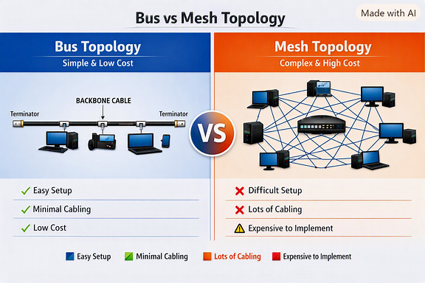

4. Hybrid topology is highly scalable because it combines two or more different
topologies (such as star, mesh, or bus), allowing the network to expand flexibly
according to organizational needs. New segments can be added without affecting the
existing network structure. In comparison, star topology is also scalable but to a
limited extent, as it depends on the capacity of the central device (switch or hub).
Once the central device reaches its port limit, expansion requires additional hardware.
Thus, hybrid topology provides greater scalability than star topology.
Sol:

Hybrid Topology
🔹 1. Structure
- Combines two or more topologies (e.g., star, mesh, bus) into one network.
- Each segment can use the topology best suited for its function.
🔹 2. Scalability
- Highly scalable — new segments or departments can be added easily.
- Expansion does not affect existing network performance.
- Ideal for large organizations with multiple buildings or departments.
🔹 3. Flexibility
- Offers design flexibility — can adapt to different network requirements.
- Supports both wired and wireless components.
🔹 4. Reliability
- Inherits the fault tolerance of mesh and the manageability of star.
- Failure in one segment doesn’t affect others.
🔹 5. Cost & Complexity
- Moderate to high cost depending on the combination of topologies.
- More complex to design and maintain than a single topology.
🔹 6. Use Case
- Suitable for universities, enterprises, and large organizations needing modular growth.
🌟 Star Topology
🔹 1. Structure
- All devices connect to a central hub or switch.
- Communication passes through this central device.
🔹 2. Scalability
- Moderately scalable — limited by the number of ports on the central device.
- Expansion requires adding more switches or hubs once capacity is reached.
🔹 3. Reliability
- Reliable for small to medium networks.
- Failure of the central hub causes total network downtime.
🔹 4. Cost & Complexity
- Lower cost and simpler setup compared to hybrid topology.
- Easy to manage and troubleshoot.
🔹 5. Use Case
- Common in offices, startups, and small networks where simplicity and reliability are key.

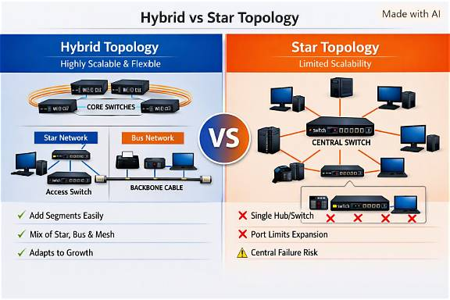

5. In terms of maintenance, star topology is relatively easy to manage because issues can
be quickly identified and isolated to a specific node or cable. Mesh topology, while
highly reliable, is difficult to maintain due to its complex structure and large number
of connections, making troubleshooting time-consuming. Bus topology is harder to
maintain than star because faults in the backbone cable can disrupt the entire network
and are difficult to locate. Hybrid topology has moderate maintenance complexity;
while it benefits from flexibility, managing multiple combined topologies requires
careful monitoring and skilled administration.

Sol :
Star Topology
- Ease of Maintenance
  - Simple to manage — each node connects directly to a central hub or switch.
  - Faults can be quickly identified and isolated to a specific node or cable.
  - Replacing or repairing a single connection doesn’t affect the rest of the network.
- Troubleshooting
  - Straightforward — the central device helps monitor and control traffic.
  - Ideal for small to medium networks where uptime and simplicity matter.
🔹 Mesh Topology
- Maintenance Complexity
  - Difficult to maintain — every node connects to multiple others.
  - Large number of cables and ports make troubleshooting time-consuming.
  - Requires skilled administrators and advanced monitoring tools.
- Reliability vs. Maintenance Trade-off
  - Extremely reliable (no single point of failure).
  - But maintenance is labor-intensive due to complex interconnections.
🔸 Bus Topology
- Maintenance Difficulty
  - Harder to maintain than star topology.
  - A fault in the backbone cable can disrupt the entire network.
  - Locating the exact fault point is challenging.
- Troubleshooting
  - Requires checking the entire cable length and terminators.
  - Suitable only for small, low-traffic networks where maintenance demands are minimal.
🧩 Hybrid Topology
- Maintenance Level
  - Moderate complexity — combines multiple topologies (star, mesh, bus).
  - Each segment may require different maintenance approaches.
  - Flexibility improves fault isolation but increases administrative effort.
- Management Requirements
  - Needs careful monitoring and skilled network administration.
  - Maintenance tools must handle diverse configurations.

